Bennekerry National School
Carlow
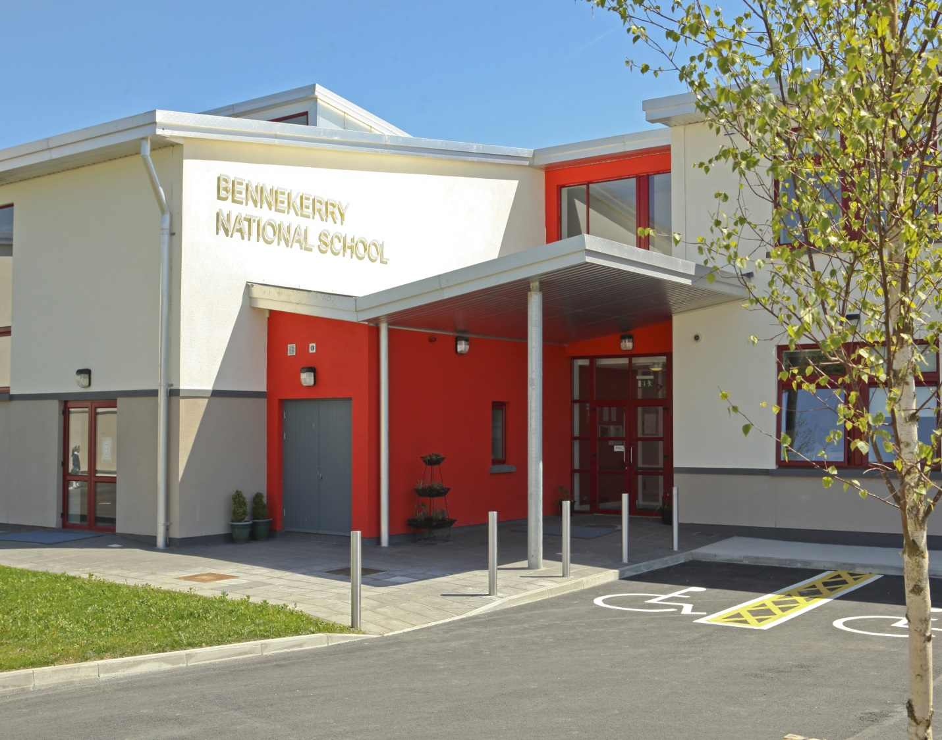
Principal: Julie Fitzmaurice bennekerry@gmail.com
Deputy Principal: Lourda Griffin Roll No:17501Q
Secretary: 059 9143495

Notification of Intention to Apply for Enrolment

Surname
(as on birth cert)
Christian Name

Date of Birth

Child’s PPSN
Address

Eircode

Parent/Guardian 1
Name

Telephone number

Email address

Parent/Guardian 2

Name

Telephone number

Email address

Number of children in family

Child’s place in family

Requested date of entry to the school

This form is not confirmation of a place in the school. An enrolment application form will be sent to you at the above address in the month of January prior to September enrolment.

Please read and sign the declaration below.
I / we wish to give notice of our intention to apply for enrolment of__________________________ to Bennekerry N.S. in the school year _________________ and request an application form to be sent to me / us in the month of October of the relevant year.
I / we understand that it is our responsibility to communicate to the school any change in our correspondence address.

Signature of Parent/Guardian ___________________________________ Date ___________________

Signature of Principal __________________________________ Date of receipt _______________________

